REST - Get country exceptional scenario
Created a new custom exception class with the name CountryNotFound
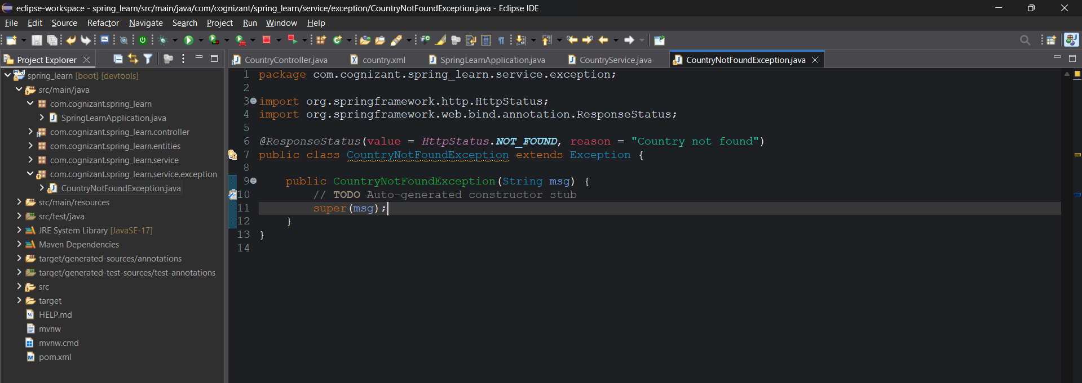
Handled exception in the service class
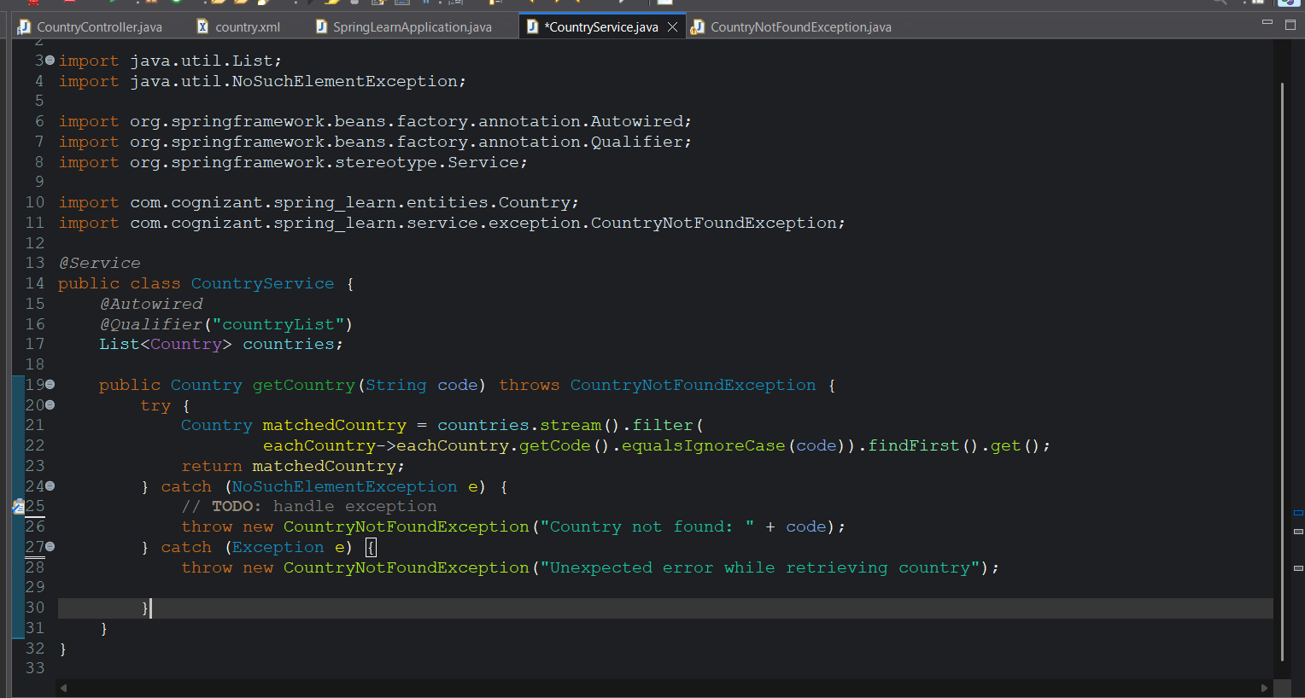
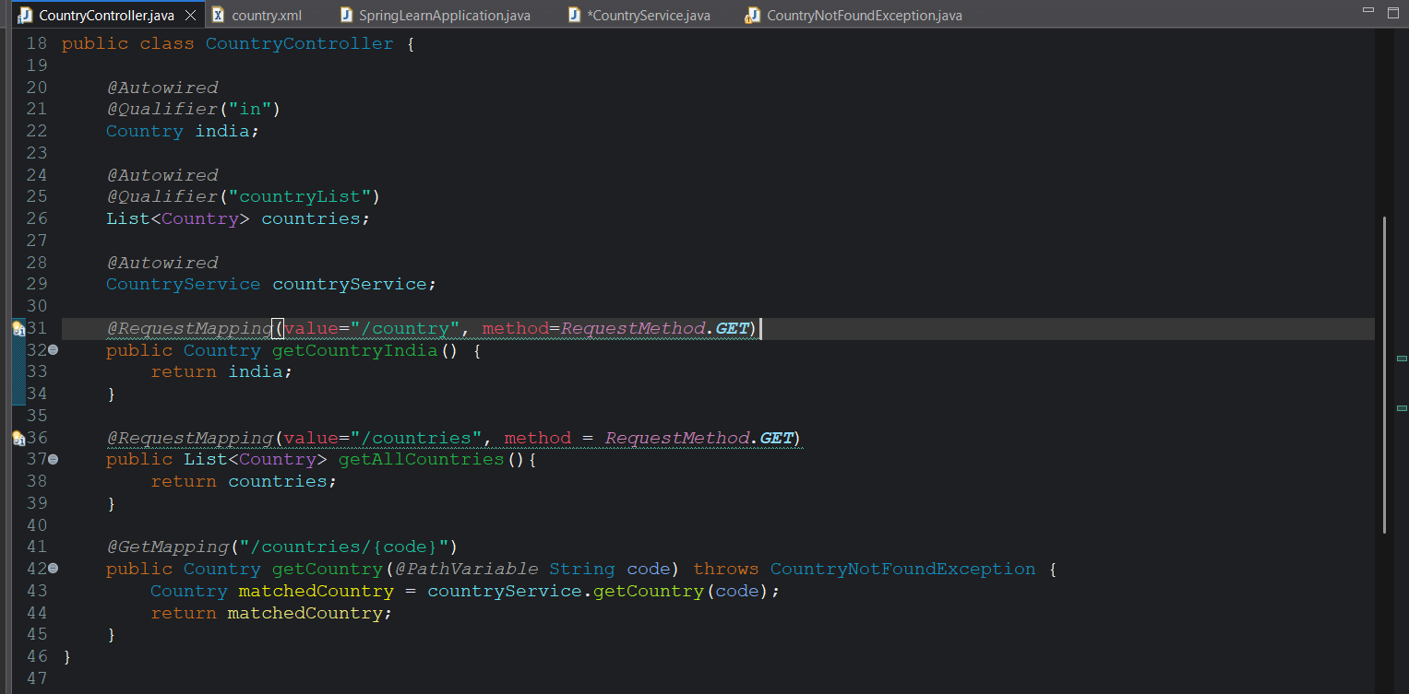
Included stack tracer = never in the application properties to avoid printing of lengthy exception message
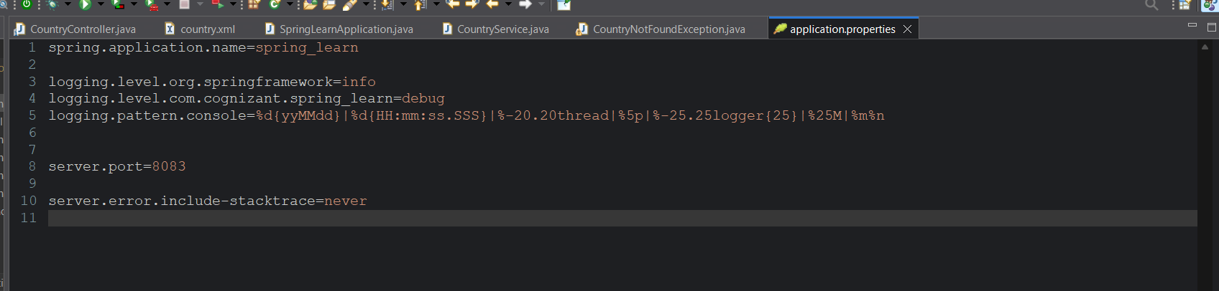
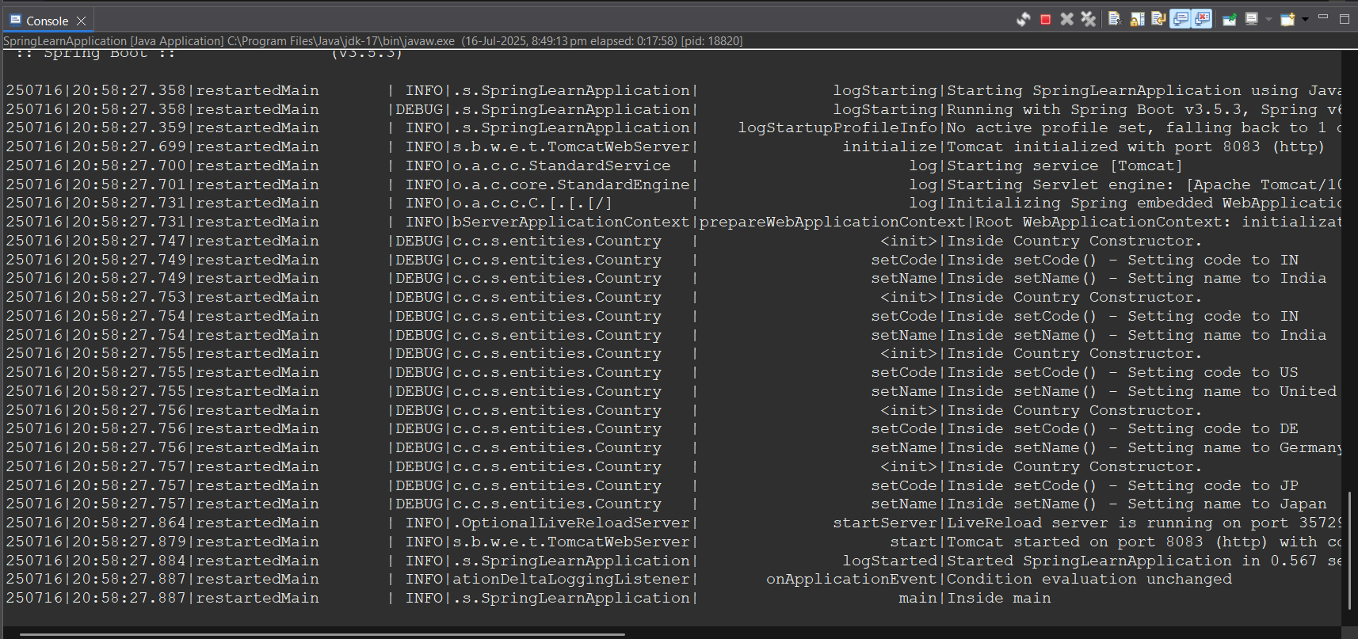
Postman:
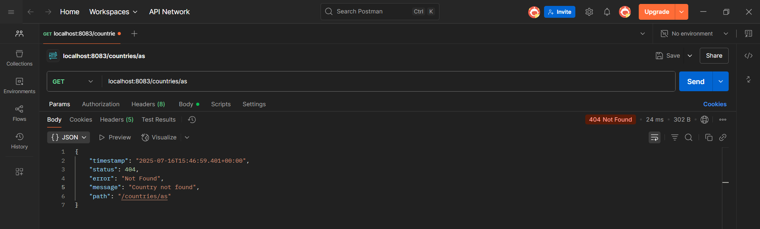
Browser:
